Profile for Mrs Sara Eley (Headteacher of Austrey and Newton Regis CE Primary Schools

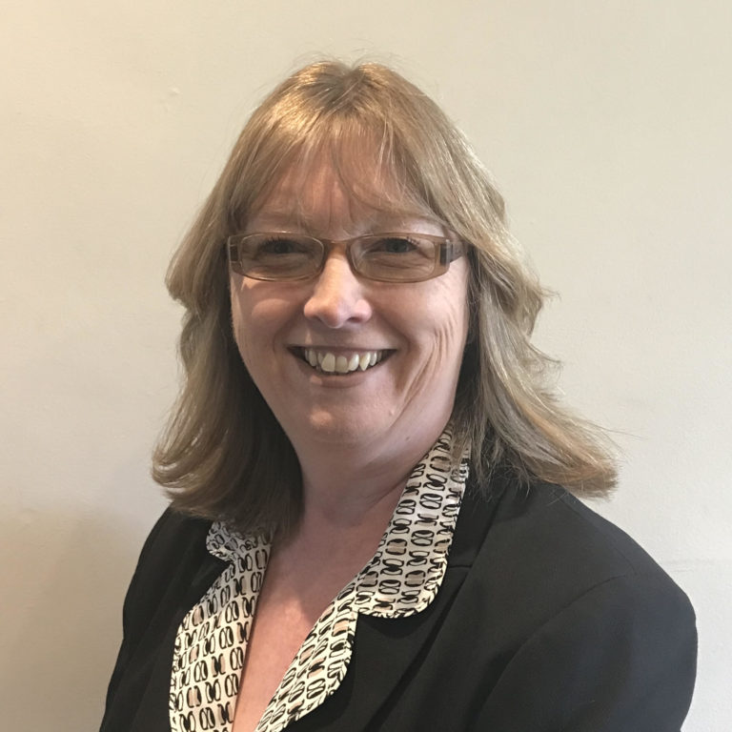

Hello, my name is Sara Eley and it is my absolute pleasure to be introducing myself as the new Headteacher of Austrey and Newton Regis CE Primary Schools, part of the Birmingham Diocese Multi-academy Trust. I took up this post on 20th April 2020. I began my teaching career in 1992 and have worked in a variety of schools, including large inner-city schools and Church Schools in Leicestershire.
I live in Tamworth with my husband and two teenage daughters. I enjoy tap dancing, reading and travelling around Europe in our campervan.
My priority as a Headteacher is encompassing the Christian values that are key to the schools and to ensure that staff and children are guided by BDMAT’s mission to enjoy ‘life in its fullness’ (John 10:10). As alongside welcoming the children of the community into a caring, secure and safe environment.

